Assignment Sheet 

**Assignment 1 :-** How to upload HTML web pages on Apache2 web server in EC-2 Instance? Please justify with step by step answers.

**Ans-**

1. sudo apt-get update -update the VM

2. sudo apt-get dist-upgrade -update dependancies

3. sudo apt install apache2 -install apache2

4. systemctl start apache2.service --for starting the apache service

5. systemctl enable apache2.service --for enabling the apache service

6. sudo systemctl status apache2 - - checking the service status

7. curl localhost:80 or vim /var/www/html/index.html -------you can edit and save the file

8. add the public IP of your EC2 VM on browser and you will be able to see the default apache index page

(I have created the server, please check the following scrrenshot)

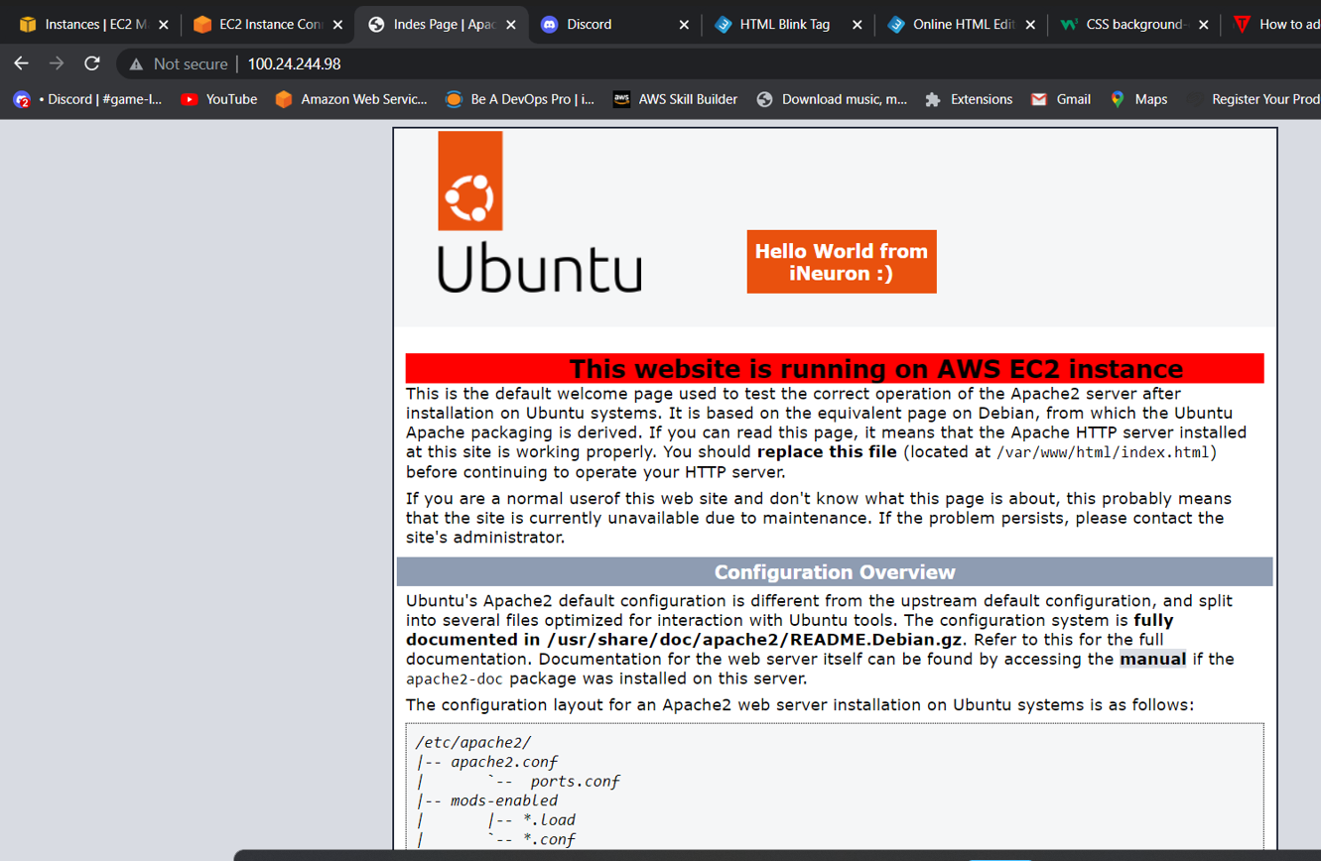

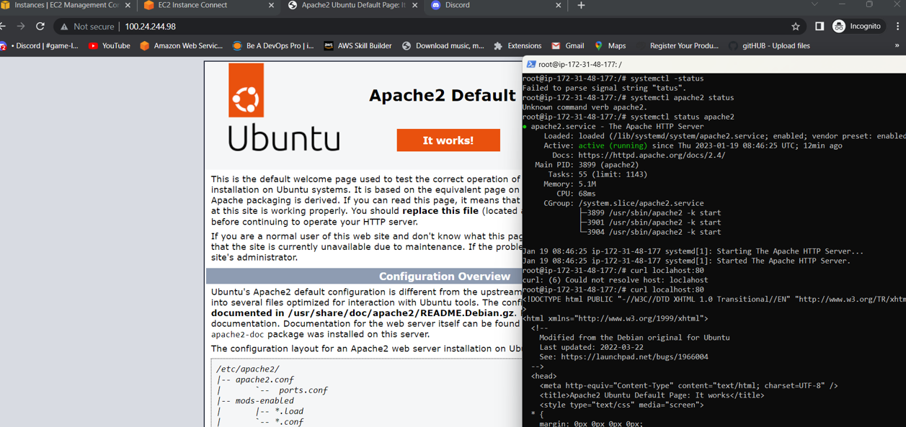

**Assignment 2 :** Create readfile.sh in which you can read the information of PWD like size, permission, date time etc.

**Ans-** 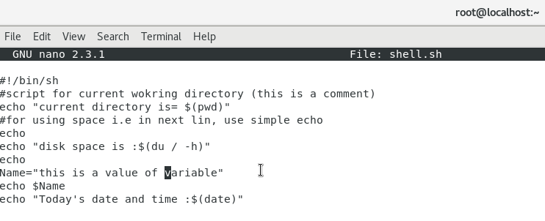

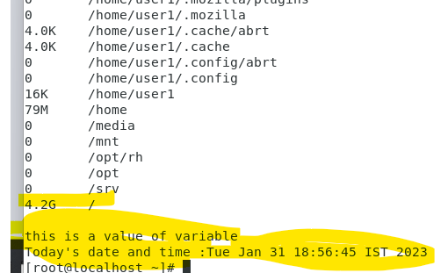

**Assignment 3** : Take an input of name from user and print Have a great day ahead {name}

**Ans –**

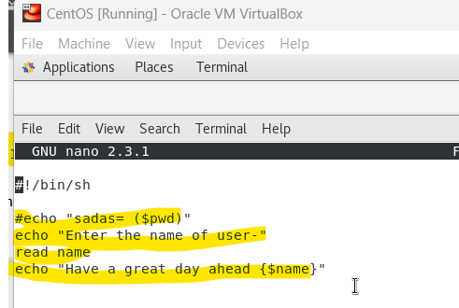

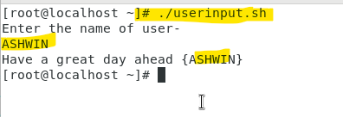

**Assignment 4 :** Let’s take a scenario of fintech app program in which we want to have three separate outputs for 3 different situations:

→The balance is less than zero

→The balance is zero

➔ The balance is above zero

For instance, in the following program, use the if, elif, else statements to display different outputs in different scenarios:

Use “if” condition to check if the balance is less than zero. If this condition evaluates to true, display the message using the echo command: “Balance is less than zero, Please add more funds else you will be charged penalty”.

If the above condition does not match, then use “elif” condition to check if the balance is equal to zero. If it evaluates to true, display the message: Balance is zero, please add funds

If none of the above condition matches, use the “else” condition to display the: Your balance is above zero.

Ans –

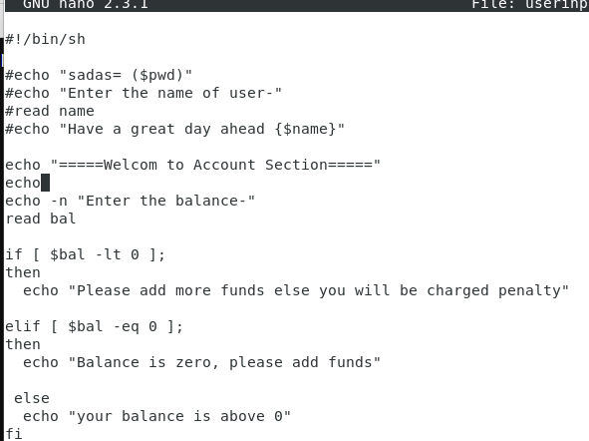

Output-

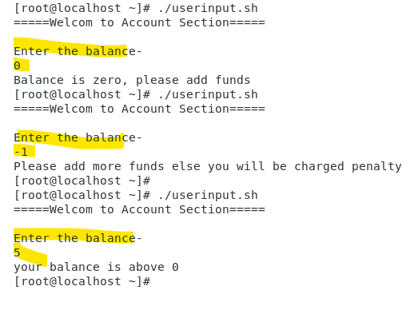

**Assignment 5** : Debug and define briefly about the following program :- #!/bin/bash# Print a message about disk useage.

space_free=$( df -h | awk '{ print $5 }' | sort -n | tail -n 1 | sed 's/%//' ) case $space_free in

[1-5]*)

echo Plenty of disk space available

[6-7]*)

echo There could be a problem in the near future

8*)

echo Maybe we should look at clearing out old files

9*)

echo We could have a serious problem on our hands soon

*)

echo Something is not quite right here

;;

Esac

**Ans** – Above program is a example for switch case.

* Space_free is a variable which contains the multiple expressions which are separated by “**|**”.
* We use switch case when we have multiple values to check. Best example is to identify the entered alphabet is vowel or not as we have to check that alphabet with 5 vowels and there will five cases and expression will be evaluated with all these cases.
* df -h will show the disk free space in human readable form
* awk '{ print $5 }' - It will print the 5th column of the displayed disk free space
* sort -n - It will sort the displayed data in ascending order
* tail -n 1 - It will show the last entry i.e. last disk free space of 5th column.
* sed 's/%// - sed is used to edit files even without opening them we can perform edit, delete substitute operation which also support pattern matching with regular expressions
* *) - -- in last case we add the displays when the system does not meets the case’s condition.